**Costco Wholesale Company's Transition to Cloud System**

Costco Wholesale, a global retail giant, is making significant strides in transforming its data infrastructure by embracing cloud architecture. This strategic move aims to address key objectives, overcome existing challenges, and implement robust pipeline and development strategies to enhance its operational efficiency and customer experience.

**Existing System:**

Costco Wholesale, known for its warehouse model and bulk sales strategy, currently works on a traditional on-premises infrastructure. While efficient, this system lacks the agility and scalability needed to meet the demands of today’s dynamic market landscape.

**Purpose:**

Costco’s move towards cloud computing is driven by the need to optimize its operational processes, enhance scalability, reduce costs, and improve overall performance.

**Vision:**

Costco’s cloud vision encompasses a comprehensive framework aimed at harnessing the power of cloud computing to unlock new levels of efficiency and innovation. By migrating key data sources such as store operations, user activity logs, and application performance metrics to cloud servers, Costco aims to help real-time inventory management, web analytics, and robust audit and reporting capabilities.

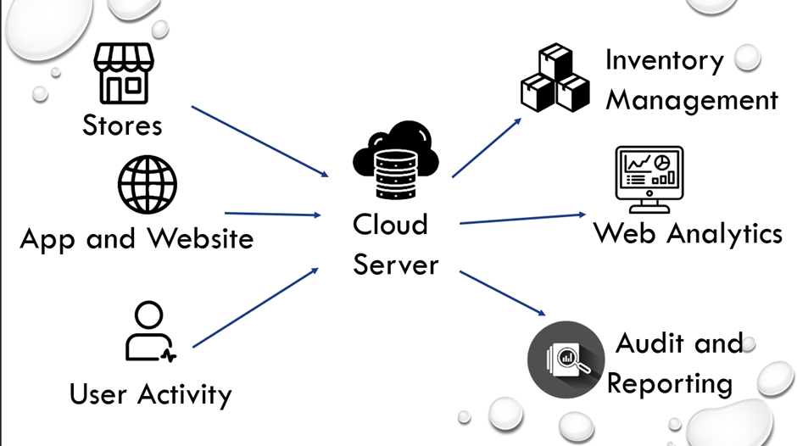

**Objectives**

**Costco's migration to the cloud is driven by the following objectives:**

**Increase Flexibility:** The company aims to enhance its ability to adapt to peak shopping seasons and unexpected spikes in online orders by leveraging cloud architecture.

**Scalability**: Costco seeks to address the challenge of handling increased workloads as it expands globally and encounters seasonal demand fluctuations

**Cost Optimization**: Managing costs while maintaining high availability and performance is a constant concern for Costco, and the cloud architecture provides avenues for achieving this balance.

**Improving Performance**: The company is focused on improving the overall performance of its data systems to ensure seamless operations and customer satisfaction.

**Problem Statement**

**Costco faces two primary challenges that have necessitated its move to cloud architecture:**

**Scalability and Performance**: The existing legacy systems struggle to handle the increased workloads resulting from the company's global expansion and seasonal demand fluctuations.

**Legacy Systems**: As Costco expands globally, its legacy systems are proving to be inadequate in addressing the evolving demands, necessitating a more scalable and efficient solution.

**Cloud Architecture**

In the cloud architecture adopted by Costco, the data sources include e-commerce, customer databases, website tracking, and geolocation information. The pipeline ingestion is facilitated through a data lake, while the data is stored and processed in a data Lakehouse, comprising bronze, silver, and gold layers. Additionally, Costco utilizes Power BI and Azure ML for creating insightful dashboards and analytics.

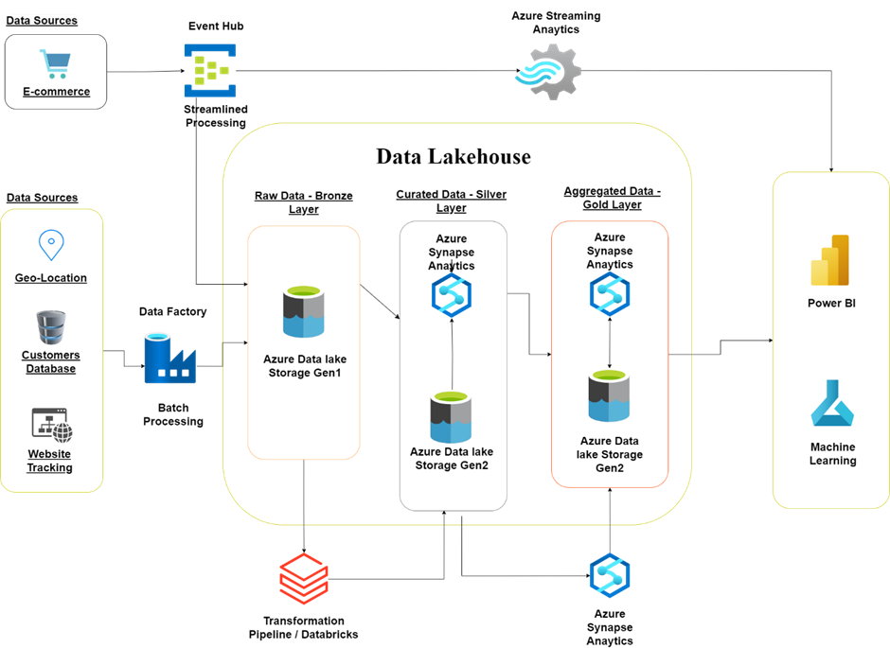

**Pipeline**

Costco’s data lake-house architecture comprises three layers - bronze, silver, and gold - to manage and process data efficiently. Raw data is ingested into the bronze layer, where it undergoes transformation and enrichment in the silver layer, culminating in valuable insights and analytics in the gold layer.

**Costco's pipeline strategy encompasses three key components:**

**Data Ingestion**: The company employs a robust data ingestion pipeline to ensure the seamless flow of data from various sources into the cloud environment.

**Data Storage**: Costco's data storage strategy involves efficient management and organization of the ingested data, ensuring its accessibility and integrity for further processing and analysis.

**Data Analysis**: The company has implemented a comprehensive data analysis pipeline to derive valuable insights and actionable intelligence from the stored data, enabling informed decision-making and strategic planning.

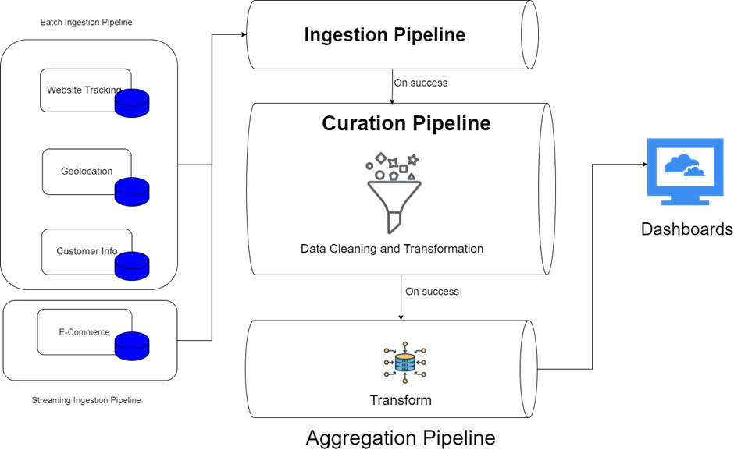

**Development Strategy**

**Costco's development strategy revolves around two crucial aspects:**

**Agile Development:** Costco adopts an agile development approach, allowing for iterative and incremental enhancements to its cloud infrastructure and services.

**Continuous Integration/Continuous Deployment (CI/CD**): Embracing CI/CD practices enables Costco to streamline deployment processes, ensuring rapid delivery of new features and updates to its cloud-based systems.

**Conclusion**

Costco Wholesale’s transition to a cloud-based infrastructure marks a significant step forward in its digital evolution. By embracing cloud computing, Costco not only addresses existing scalability and performance challenges but also lays the foundation for future innovation and growth in the competitive retail landscape.